
Focus Brain Therapy
June 05, 2026
Concept/Mockup – Client Feedback – Learn More Content

Existing Client website: https://focusbraintherapy.com/
Concept/Mockup: https://focusbrain-kappa.vercel.app/

BUTTON TEXT CHANGE
Please rename button to: Book a Consultation
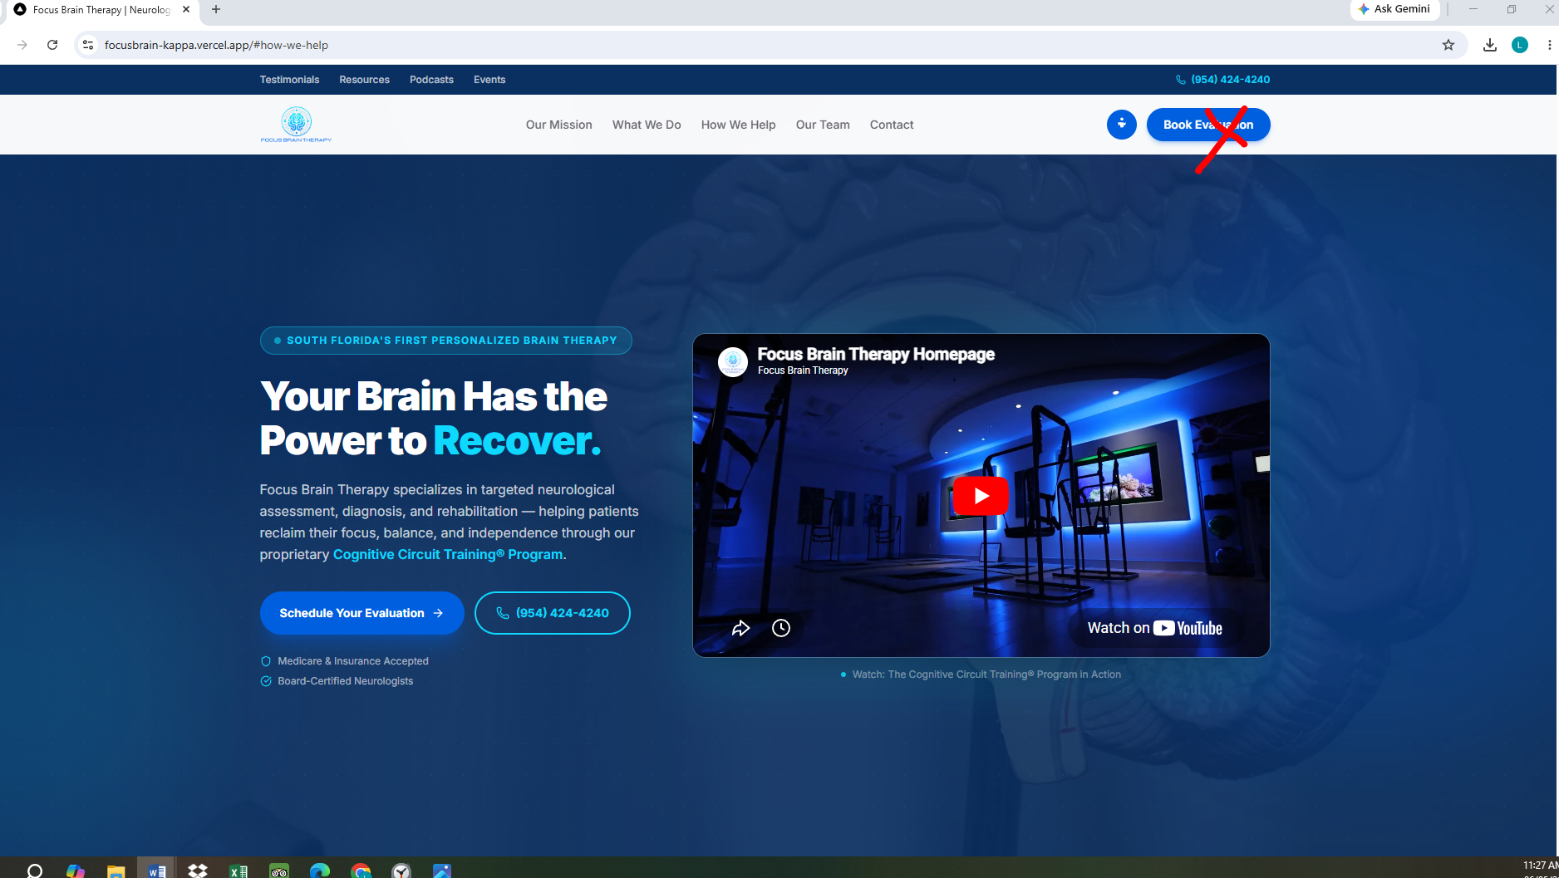

LEARN MORE
Below is the text/content for the Learn More link for the conditions in this section: (they should be in order of how they are shown in the chart)
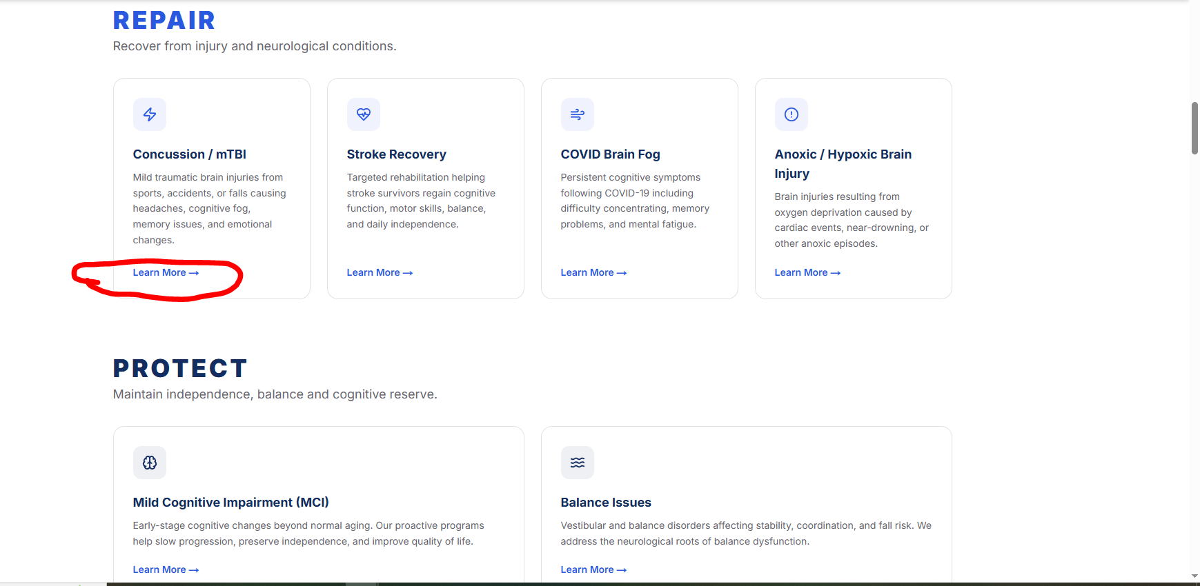
CONCUSSION / MILD TRAUMATIC BRAIN INJURY
When the Brain's Communication System Gets Shaken
A concussion is often called a "mild" traumatic brain injury, but there is nothing mild about the symptoms it can create.
A concussion occurs when a blow, bump, fall, motor vehicle accident, workplace injury, sports collision, or sudden whiplash movement causes the brain to move rapidly inside the skull. Even though the injury cannot appear on a standard CT scan or MRI, the brain's communication system can be disrupted.
Many people are told their scans are normal, yet they continue to struggle with headaches, brain fog, memory problems, dizziness, fatigue, anxiety, sleep disturbances, and difficulty concentrating.

What Happens Inside the Brain?
Think of your brain as a city filled with highways carrying information.
After a concussion, those highways become congested. Messages still travel, but they move more slowly and require significantly more energy.
As a result, everyday activities such as working, driving, making decisions, reading, exercising, or tolerating noise can become exhausting.
Common symptoms include:
• Brain fog
• Memory problems
• Slower processing speed
• Headaches
• Dizziness
• Balance difficulties
• Light and noise sensitivity
• Anxiety and irritability
• Mental fatigue
How The Cognitive Circuit Training® Program Can Help
The Cognitive Circuit Training® Program (CCT®) is designed to stimulate neuroplasticity—the brain's ability to create new connections and strengthen and repair existing ones.
Each 90-minute session combines:
• Cognitive training
• Balance training
• Visual and oculomotor exercises
• Sensory integration
• Multisensory learning
• Emotional regulation strategies
Rather than focusing on a single symptom, the CCT® Program works to improve overall brain efficiency and communication.
Our Goal
Help the brain communicate more efficiently, improve cognitive endurance, reduce overload, and support a successful return to work, family life, exercise, and daily activities.
Your Brain Isn't Broken. It's Trying to Reconnect.

STROKE RECOVERY
When Blood Flow to the Brain Is Interrupted
A stroke occurs when blood flow to part of the brain is blocked or when a blood vessel ruptures. Without adequate oxygen and nutrients, brain cells can become damaged.
Depending on the area affected, a stroke can impact movement, balance, speech, memory, attention, emotional regulation, problem-solving, and processing speed.
Recovery often continues long after the initial medical event.
What Happens Inside the Brain?
Imagine a major highway suddenly closing.
Traffic backs up, alternate routes become overloaded, and reaching certain destinations becomes difficult.
The brain faces a similar challenge after a stroke. Areas that once performed certain functions can no longer work efficiently, requiring other brain networks to help compensate.
How The Cognitive Circuit Training® Program Can Help
The brain retains the ability to adapt and reorganize throughout life.
The CCT® Program is designed to challenge multiple brain systems simultaneously through:
• Cognitive exercises
• Balance activities
• Visual processing tasks
• Motor planning activities
• Multisensory stimulation
• Emotional regulation training
These activities can help strengthen communication between surviving brain networks and support functional recovery.
Our Goal
To help improve cognitive performance, confidence, endurance, balance, and overall quality of life after stroke.
The Brain Can Find New Routes.

COVID BRAIN FOG
When the Infection Is Gone but the Symptoms Remain
Many people recover from COVID-19 only to find that their thinking never fully returns to normal.
Months and years after the infection has been resolved, they can continue experiencing:
• Brain fog
• Difficulty concentrating
• Memory problems
• Mental fatigue
• Slower processing speed
• Reduced productivity
• Word-finding difficulties
These symptoms are real and can significantly affect work, family life, and daily functioning.
What Happens Inside the Brain?
Researchers believe COVID-related cognitive symptoms can involve inflammation, changes in blood flow, immune system activation, nervous system dysfunction, and disruptions in brain network efficiency.
Many patients describe feeling as though their brain is "stuck in a fog."
How The Cognitive Circuit Training® Program Can Help
The CCT® Program is designed to activate multiple brain systems at once through:
• Cognitive challenges
• Visual processing exercises
• Balance activities
• Multisensory learning
• Attention training
• Emotional regulation techniques
The goal is to gradually improve communication, endurance, and efficiency throughout the brain.

Our Goal
To help individuals regain clarity, confidence, mental stamina, and cognitive performance.
The Virus Left. The Brain Fog Stayed.

ANOXIC / HYPOXIC BRAIN INJURY
When the Brain Doesn't Receive Enough Oxygen
The brain requires a constant supply of oxygen to function properly.
Anoxic brain injury occurs when oxygen is completely interrupted.
Hypoxic brain injury occurs when oxygen levels are significantly reduced.
These injuries can result from:
• Cardiac arrest
• Drowning incidents
• Choking events
• Respiratory failure
• Carbon monoxide exposure
• Surgical complications
Even brief oxygen deprivation can affect memory, attention, judgment, processing speed, and executive function.
What Happens Inside the Brain?
The brain is one of the most energy-demanding organs in the body.
Without oxygen, brain cells struggle to produce the energy required for communication.
Some networks can become less efficient, while others attempt to compensate.
How The Cognitive Circuit Training® Program Can Help
THE CCT® Program is designed to stimulate brain activity through structured challenges that engage:
• Attention
• Memory
• Balance
• Visual processing
• Motor coordination
• Emotional regulation
Repeated practice can help strengthen existing pathways and encourage neuroplastic adaptation.
Our Goal
To help improve functional performance, cognitive endurance, confidence, and independence.
When Oxygen Stops, Brain Function Changes.

MILD COGNITIVE IMPAIRMENT (MCI)
When Memory Changes Are More Than Normal Aging
Most people occasionally forget a name, misplace their keys, or walk into a room and forget why they went there.
Mild Cognitive Impairment (MCI) occurs when changes in memory, attention, processing speed, or thinking abilities become more noticeable than expected for normal aging, yet are not severe enough to interfere significantly with daily independence.
Individuals with MCI often recognize that something feels different.
They can find themselves forgetting appointments, struggling to recall conversations, taking longer to complete familiar tasks, or having difficulty finding the right words.
What Happens Inside the Brain?
As we age, the brain naturally undergoes changes.
However, in MCI, some brain networks become less efficient and communication between brain regions can begin to slow.
Think of it as a city where some roads are becoming narrower and traffic is starting to back up.
The good news is that the brain retains the ability to adapt throughout life.
This ability is called neuroplasticity.
The brain can continue building new pathways, strengthening existing connections, and increasing cognitive reserve when properly challenged.
Common Symptoms
• Forgetting recent conversations
• Misplacing items more frequently
• Difficulty finding words
• Reduced attention and focus
• Slower processing speed
• Difficulty multitasking
• Increased mental fatigue
• Feeling less mentally sharp
How The Cognitive Circuit Training® Program Can Help
The Cognitive Circuit Training® Program (CCT ®) is designed to challenge multiple brain systems simultaneously.
Each session combines:
• Cognitive exercises
• Balance training
• Visual processing activities
• Multisensory learning
• Reaction-time training
• Emotional regulation techniques
• Movement-based brain stimulation
The goal is to stimulate neuroplasticity and increase cognitive reserve; the brain's ability to compensate for age-related changes and neurological stressors.
Rather than simply exercising memory, The CCT® Program trains multiple brain networks at the same time.
Why Cognitive Reserve Matters
Think of cognitive reserve as having extra roads available when traffic becomes heavy.
The more pathways the brain has available, the better it can adapt to aging and neurological challenges.
Building cognitive reserve can help support:
• Memory
• Attention
• Processing speed
• Problem solving
• Daily functioning
• Long-term brain health
Our Goal
To help individuals maintain independence, improve cognitive performance, strengthen cognitive reserve, and support healthy brain aging.
Aging Is Inevitable. Cognitive Decline Is Not.

BALANCE ISSUES
When the World Doesn't Feel Steady
Balance problems can make everyday activities challenging and sometimes frightening.
Many people describe feeling unsteady, off-balance, dizzy, lightheaded, or uncertain when walking.
Others can notice increased falls, difficulty navigating crowds, trouble walking on uneven surfaces, or feeling uncomfortable when turning their head quickly.
Balance problems can occur at any age and often involve much more than the ears.
What Happens Inside the Brain?
Balance is controlled by several systems working together:
The Eyes
Provide information about where you are in space.
The Inner Ear
Detects movement and changes in position.
The Body
Sensors in muscles and joints tell the brain where the body is located.
The Brain
Acts as the control center, constantly integrating information from all three systems.
When communication between these systems becomes disrupted, balance can suffer.
Common Causes of Balance Problems
• Concussion
• Stroke
• Vestibular disorders
• Aging
• Neurological conditions
• Inner ear dysfunction
• COVID-related neurological changes
• Medication side effects
• Deconditioning

Common Symptoms
• Feeling unsteady
• Dizziness
• Increased falls
• Motion sensitivity
• Difficulty walking in crowds
• Difficulty walking in the dark
• Trouble turning quickly
• Fear of falling
• Reduced confidence
How The Cognitive Circuit Training® Program Can Help
THE CCT® Program incorporates balance training into a comprehensive neuroplasticity-based program.
Patients can participate in:
• Dynamic balance activities
• Visual tracking exercises
• Vestibular stimulation
• Cognitive tasks performed during movement
• Sensory integration activities
• Reaction-time training
• Dual-task exercises
These activities challenge the brain to process information more efficiently while maintaining stability and coordination.

Why Balance Is a Brain Function
Many people assume balance is simply a muscle problem.
In reality, balance is a complex brain function requiring constant communication between the eyes, inner ears, muscles, joints, and brain.
Improving balance often means improving how the brain processes information.
Our Goal
To help individuals move more confidently, reduce fall risk, improve stability, and regain independence.
Balance Doesn't Start in the Feet. It Starts in the Brain.

SPORTS PERFORMANCE ENHANCEMENT
Your Body Can Only Perform as Fast as Your Brain
Athletes spend countless hours improving strength, speed, endurance, flexibility, and technique.
Yet every movement begins in one place—the brain.
Whether it's tracking a fast-moving ball, reacting to an opponent, maintaining balance under pressure, making split-second decisions, or staying mentally composed during competition, the brain serves as the command center for athletic performance.
The difference between good and great is often measured in milliseconds.
What Happens Inside the Brain?
Elite athletes don't simply have stronger muscles.
They often have faster communication between brain networks responsible for:
• Reaction time
• Visual processing
• Decision-making
• Balance
• Coordination
• Focus
• Emotional control
• Motor planning
The brain must constantly process information, predict outcomes, and send commands to the body with incredible speed and accuracy.
Why Athletes Hit Performance Plateaus
Many athletes focus almost entirely on physical training while neglecting the system directing every movement.
As competition levels increase, physical differences between athletes become smaller.
Brain efficiency often becomes the deciding factor.
How The Cognitive Circuit Training® Program Can Help
The Cognitive Circuit Training® Program (CCT®) combines:
• Reaction-time training
• Visual tracking exercises
• Balance training
• Multisensory learning
• Cognitive processing challenges
• Decision-making drills
• Emotional regulation techniques
• Dual-task performance activities
The goal is to improve how efficiently the brain processes information and communicates with the body.
Potential Benefits
• Faster reaction time
• Improved focus
• Better hand-eye coordination
• Enhanced balance
• Faster decision making
• Improved game awareness
• Better emotional control under pressure
• Increased mental endurance
Our Goal
To help athletes train the most important performance organ in the body; the BRAIN.
Every great play begins in the brain.

EXECUTIVE BRAIN ENHANCEMENT
Peak Performance Starts Above the Neck
Executives are expected to make high-level decisions, solve complex problems, manage stress, communicate effectively, and maintain focus for hours at a time.
Yet few professionals actively train the organ responsible for all of those abilities.
Just as elite athletes train for physical performance, executives can train for cognitive performance.
What Happens Inside the Brain?
Leadership places enormous demands on the brain.
Every day executives rely on:
• Strategic thinking
• Problem solving
• Memory
• Focus
• Emotional intelligence
• Decision making
• Cognitive flexibility
• Stress management
Over time, stress, aging, poor sleep, and constant digital stimulation can reduce mental efficiency and cognitive endurance.
The Hidden Cost of Mental Fatigue
Many executives notice:
• Difficulty concentrating
• Mental fatigue
• Slower recall
• Reduced productivity
• Increased stress
• Decision fatigue
• Difficulty multitasking
• Reduced creativity
These changes are often viewed as normal consequences of success.
They don't have to be.
How The Cognitive Circuit Training® Program Can Help
THE CCT® PROGRAM combines:
• Advanced cognitive training
• Balance and coordination activities
• Multisensory learning
• Attention and focus exercises
• Visual processing tasks
• Emotional regulation techniques
• Brain endurance training
The program is designed to strengthen the brain's communication systems while supporting neuroplasticity and cognitive reserve.
Potential Benefits
• Sharper focus
• Faster decision making
• Improved productivity
• Better memory
• Greater mental stamina
• Enhanced creativity
• Improved stress resilience
• Stronger executive function
Why Cognitive Reserve Matters
Think of cognitive reserve as having additional lanes on the highway.
The more reserve the brain has, the better it can adapt to stress, aging, and increasing cognitive demands.
Building cognitive reserve today helps support performance tomorrow.
Our Goal
To help leaders think clearly, perform consistently, and maintain peak cognitive function throughout their careers.
STUDENT BRAIN ENHANCEMENT
Learning Faster Starts With a Better Performing Brain
Students today face more mental demands than ever before.
School requires constant attention, memory, processing speed, organization, focus, emotional regulation, and the ability to absorb large amounts of information quickly.
Many students work harder and harder, yet continue struggling because they are trying to learn with an overloaded brain.
The goal isn't simply studying more.
The goal is creating a brain that learns more efficiently.
What Happens Inside the Brain?
Learning requires multiple brain systems working together simultaneously.
A student must:
• Pay attention
• Process information
• Store information
• Retrieve information
• Organize thoughts
• Manage distractions
• Control emotions
• Maintain mental stamina
When these systems become overwhelmed, learning becomes slower and more frustrating.
Why Some Students Learn Faster
Successful students often possess stronger cognitive skills, including:
• Attention
• Working memory
• Processing speed
• Cognitive flexibility
• Executive function
• Emotional regulation
These skills can often be strengthened through targeted brain training.
How The Cognitive Circuit Training® Program Can Help
THE CCT® Program challenges multiple learning systems simultaneously through:
• Cognitive exercises
• Multisensory learning
• Balance training
• Visual processing activities
• Attention training
• Memory challenges
• Emotional regulation strategies
• Movement-based learning
The goal is to improve how efficiently the brain learns, stores, and retrieves information.
Potential Benefits
• Improved focus
• Better memory
• Faster processing speed
• Increased concentration
• Improved test performance
• Better organization
• Reduced mental fatigue
• Greater confidence
Our Goal
To help students build stronger learning skills, improve academic performance, and develop a brain that is prepared for lifelong success.
Hero Headline
Don't Just Study Harder. Train Your Brain Smarter.
Image Concept
A student sits at a desk surrounded by floating textbooks.
Above the student's head, a glowing brain creates interconnected pathways linking mathematics, science, reading, music, and language.
The pathways resemble highways connecting different parts of a growing city.
Caption:
The stronger the connections, the easier learning becomes.

